Dear parents and campers,

Congratulation, you are registered for our 2018 Summer Technology Camp at Boise State University! We are beyond excited to meet each of you and help each camper excel to the best of their ability. Our camp offers multiple courses including:

1) Coding/Programming using MIT’s Scratch program

2) Create your own story with iPad’s including personalized videos using iMovie, and

3) App/Game Development that will teach the skills to create whatever you can imagine!

Not only will we be learning with state of the art technology in computer labs on campus, we will be doing a lot outdoors while exploring the campus and museums of Boise! We will hopefully have opportunities to have a Rec Center Night, head to the new History Museum, and maybe even a trip to Jump Time! *We do have liability and waiver forms attached for you to sign before arriving to camp.*

Breakfast and Lunch options have been arranged in the Boise River Cafe, the regular eatery for all college students on campus. For dinner campers will experience Panda Express, Costa Vida, and Flying Pie Pizza and more! All three daily meals are included in the cost of the camp.

Overnight campers’ check-in on ***Sunday, June 24th, 2018 at 4:00 PM*** at ***Keiser Hall on the BSU Campus*** *(marked on the attached map)*. However, we understand that issues may arise so if your camper is unable to arrive at this time, please contact our Camp Director Rae Bradley at (208) 484-5478 to make arrangements. On ***Friday, June 29th, at 2:00 PM at Keiser Hall*** we will have a final showcase, so campers can show their parents what they’ve been creating during camp, this too will be located at Keiser Hall *All day and overnight campers need to be picked up by 4:00pm on Friday*.

Campers, we can’t wait to spend the week helping you learn and grow while making lifelong friends and memories! Parents, thank you so much for choosing to send your kids to our camp, because with your support these campers can begin to change the world through technology. We are looking forward to June 24th and if you have any questions feel free to contact us at [getsetincorg@gmail.com](mailto:getsetincorg@gmail.com) or call us at (208) 433-0289, thank you, and we will see you there!

*Sincerely,*

*GetSetInc Team*

***Included in this packet:***

* Welcome letter
* What to Pack List
* Boise State University Map
* Sample Schedule
* Parental Gmail Account info:
  + <http://www.connectsafely.org/google-now-letting-parents-set-up-accounts-for-kids-under-13/>
* Waivers, Liability, and Emergency contact forms

**GetSetInc Summer Camp Checklist**

What Should My Camper Bring? (Label Everything Please!)

* Water bottle with their name on it (Preferably one they can use all week)
* Clothes - remember it’s going to be hot!
* Tennis shoes – we will be doing lots of walking and games
* Flip flops/shower shoes - optional but recommended
* Pen or pencil
* Spiral Notebook
* Toiletries
* Sunscreen
* Sunglasses
* Swimsuit (optional)
* Snacks (optional)
* iPads/laptops (optional) We supply if you don’t bring one
* **\*Linens, towels and pillows are provided**

What Should My Camper Not Bring?

* Tobacco
* Alcohol
* Drugs
* Fireworks
* Knives
* Guns
* Pets
* Lighters/matches

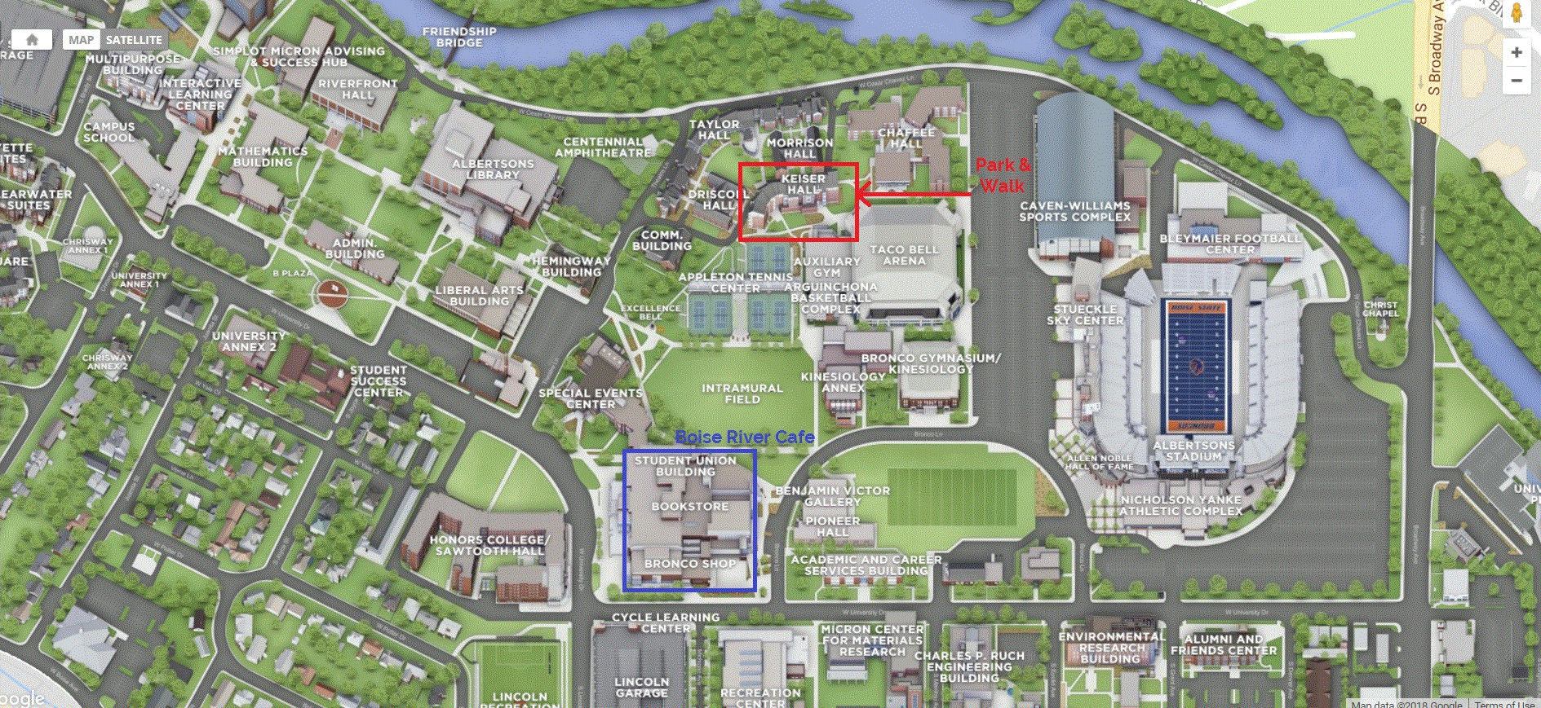

**Get Started making a Gmail account for your child to use at camp**

Family Link is available by invitation only to parents of kids under 13 years old‡. To get started, you’ll need:

* To create a Google Account for your kid through Family Link.
* A [compatible Android device](https://support.google.com/nexus/answer/4457705) for your kid*.
* Your own device (Android or iPhone).
* Your own Google Account.
* To be in the U.S.

[Request Invite](https://families.google.com/familylink-earlyaccess)

# <https://families.google.com/familylink/privacy/notice/>

# Gmail & your kid's Google Account When you create a Google Account for your kid under 13, they can use Gmail to send and receive email.

## How Gmail works

## For the most part, Gmail will be the same for kids as it is for adults. There are only a few Gmail features that aren't available to kids:

* **Ads:** Google won't serve ads in Gmail, or process Gmail messages for advertising purposes.
* **Automatic forwarding:** Kids can't automatically forward emails to another email address.
* **Gmail offline:** If their device isn't connected to the Internet, kids can’t read, send, or search their Gmail emails.
* **Google+:** Kids cannot use any Google+ features available in Gmail.
* **Labs:** Kids can’t turn on experimental Gmail features.
* **Mail delegation:** Kids can't give someone else access to read, send, or delete their emails.
* **Spam:** If Gmail identifies an email as spam, it won't get delivered to your kid's inbox or spam folder.

**Creating strong passwords**One of the easiest ways to help your kid protect their information online is to keep strong, secure passwords.   
**How to make a strong password**

* Add numbers, symbols, and mixed-case letters
* Avoid info that's easy to guess, like 12345 or "password"
* Avoid personal info, like birthdays or addresses
* Make passwords unique
* Update passwords regularly

**Tips for young kids**To create passwords that are easier to remember, try using a favorite song or phrase. And if it helps to write your kid's passwords down, use hints instead. For example, if the password is Str@wberry30, write the hint "favorite ice cream @ + favorite number."

Gmail account___________________________ Gmail password______________________________________

**2017 SUMMER CAMP PARTICIPANT Release Form-Health Care Release-Gmail Account**Every Participant must have a completed and signed release form to turn in at registration on the first day of camp in order to participate.

___________________________________________ ___________________________________________ ___________ _____________________ Minor's Name Name of Parent/Legal Guardian Grade Birth Date _________________________________________________ _______________________________________________ ______________________________ Address Parent/Legal Guardian Cell Phone Camp Class __________________________________________________ _________________________________________ _____________________________________ City, State, & Zip School School Address __________________________________________________ ______________________________________________________________________________ Phone Number School City, State, & Zip

**Liability Release**. For good and valuable consideration, the receipt and sufficiency of which are hereby acknowledged, I, ___________________________________ as parent or legal guardian of __________________________________________________ ,a minor (hereinafter "Minor"), hereby grant the permission necessary to allow Minor to participate in the above camp to be conducted by GetSetInc. I, in my own behalf and on behalf of Minor, further agree to release and to hold harmless GetSetInc, GetSetInc Sponsors, the Hosting site, (university, hotel, convention center, high school) on whose premises the Camp will occur (Boise State University) the affiliates of GetSetInc, Sponsors, the Location, and the respective directors, officers, representatives, members, and employees of GetSetInc, the Location and their respective affiliates (hereinafter collectively "Releasees") from any and all liability whether caused by the negligence of the Releasees or otherwise for any claim, judgment, loss, liability, cost and expenses arising out of or connected with the Camp, including any claim arising out of or connected with any illness or injury (minimal, serious, catastrophic and / or death) that Minor may incur or sustain during the Camp, all activities associated with the Camp and while traveling to and from the site for the Camp.   
I hereby warrant that I have read this Liability Release in its entirety and fully understand its contents. I am aware that this Liability Release releases Releasees from liability and contains an acknowledgement of my voluntary and knowing assumption of the risk of injury or illness. I further acknowledge that nothing in this Liability Release constitutes a guarantee that the Camp will occur. I have signed this document voluntarily and of my own free will.

Signature of Parent or Legal Guardian X ________________________________________________________________ Date ________________________________

**Medical Release**. I, in my own behalf and on behalf of Minor, acknowledge and agree that such participation subjects Minor to possibility of physical illness or injury (minimal, serious, catastrophic and/ or death) and that I, in my own behalf and on behalf of Minor, acknowledge that Minor is assuming the risk of such illness or injury by participating in the camp. In the event of such illness or injury, I authorize GetSetInc to obtain necessary medical treatment of Minor and hereby, in my own behalf and on behalf of Minor, release and hold harmless Releasees in the exercises of this authority. I further acknowledge and understand that I will be responsible for any and all medical and related bills that may be incurred on behalf of Minor for any illness or injury that Minor may sustain during the Camp and while traveling to and from the site for the Camp whether or not the Camp actually occurs.

**Appearance Agreement.** I understand that GetSetInc from time to time produces promotional material relating to its programs. I understand that as a participant at the Camp, Minor may be included in videotapes, photographs, DVDs, Podcasts and/or videocasts taken during the Camp. Therefore, without reservation or limitations, I, in my own behalf and on behalf of Minor, hereby assign, transfer and grant to GetSetInc, its successors, assignees, licensees, sponsors, any television networks, and all other commercial exhibitors the exclusive right to photograph and / or videotape Minor and to utilize such videotapes and photographs and Minor's name, face, likeness, voice and appearance as a part of the Camp, in advertising and promoting the Camp or in advertising and promoting similar future events. I further understand that neither GetSetInc nor any third party is under any obligation to exercise any of the foregoing rights, licenses and privileges. I, in my own behalf and on behalf of the minor, waive any right to inspect or approve the copies of any promotional materials related thereto.

I represent that any medication to which Minor is allergic or medications that Minor is currently taking are listed below. I agree that Minor shall bring medications which Minor is currently taking with  him/her to the Camp and that he/she shall consume the prescribed dosage for such medications. **GetSetInc will not administer or  
supply any type of medication at camp.**   Medications (if any) ________________________________________________________ Allergic to (if any) ______________________________________________ I acknowledge that Minor suffers from the following conditions ___________________________________________________________________________________ Family Doctor _____________________________________________________________ Minor Birthdate: ______________________________________________ Emergency Information: Name: _______________________________________________ Daytime Phone ______________________________________________ Evening Phone __________________________________________________ Phone Number_________________________________________________________ Address: _______________________________________________________City, State, Zip__________________________________________________________

I, in my own behalf and on behalf of Minor, hereby warrant that I have read this Participant Release and Waiver Form in its entirety and fully understand its contents. I, in my own behalf and on behalf of Minor, am aware that this Participant Release and Waiver Form releases Releasees from liability and contains an acknowledgement of my voluntary and knowing assumption of the risk of injury or illness. I, in my own behalf and on behalf of Minor, further acknowledge that nothing in this Participant Release and Waiver Form constitutes a guarantee that the Camp will occur. I, in my own behalf and on behalf of Minor, have signed this document voluntarily and of my own free will.

Signature of Parent or Legal Guardian X ________________________________________________________________ Date ______________________________

Relationship to Minor________________________________________________________________________________ Date _________________________________ I, identified above as Minor, acknowledge that I have read this Release and Waiver form.    
Signature of Minor X ________________________________________________________________________________ Date ____________________________   
Gmail account_____________________________________________________ Gmail password_________________________________________

